**GUI notes**

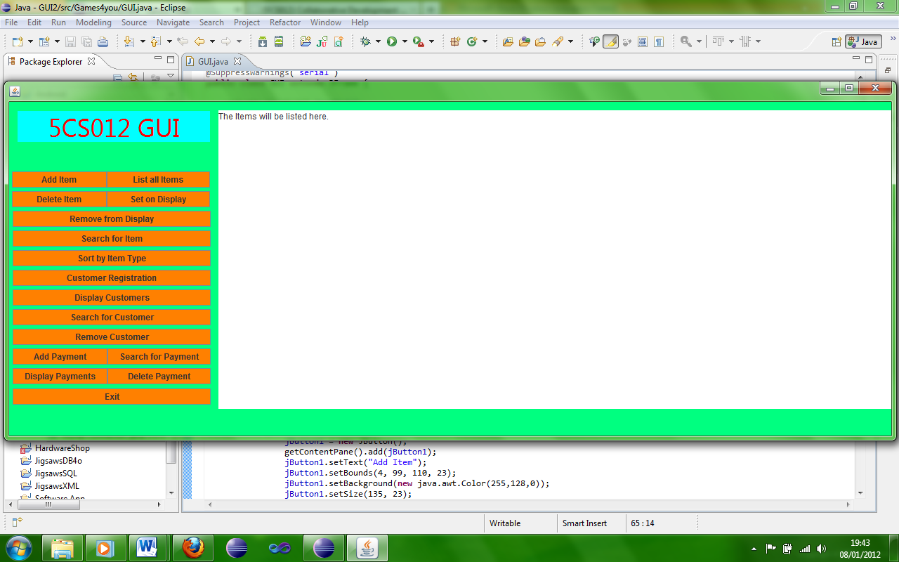

Here the program is seen running, the list of buttons on the left are the users options, and the white box is the programs output.

Here the buttons for the users input are located, the user can add and item/customer/payment, list these, search and sort them, delete as well as change whether an item is on display or not.

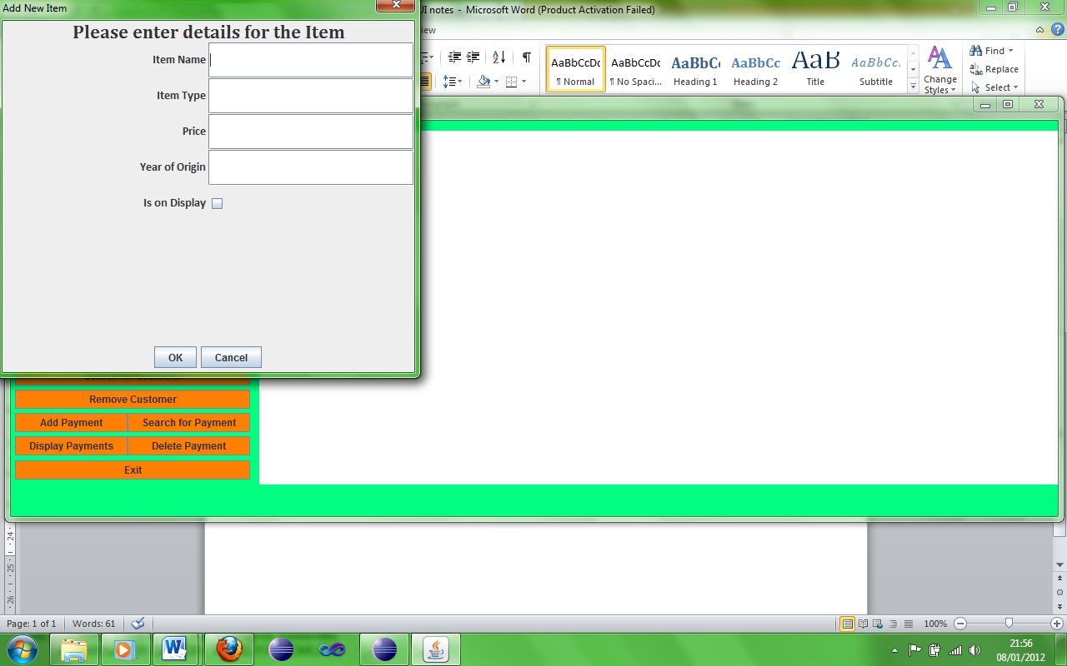Here the add item button has been selected and the add new item box has appeared allowing for input.

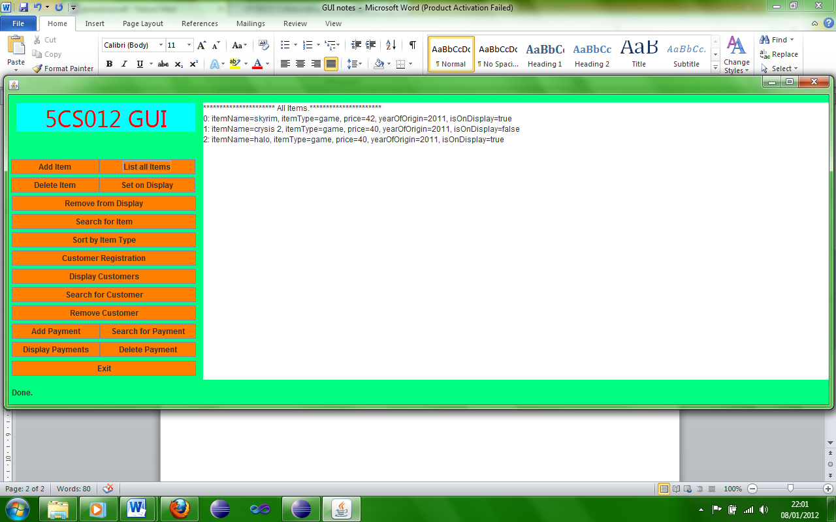Here the programs output is displayed showing clearly all of the items added by the user.

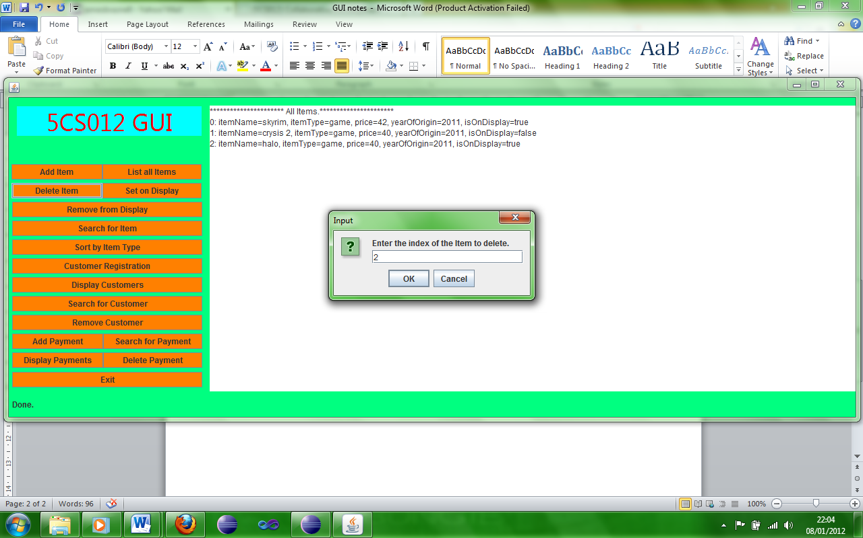

To delete an item/customer/payment, simply click the delete button for what needs removing, enter the index of the item you wish to delete and press ok.

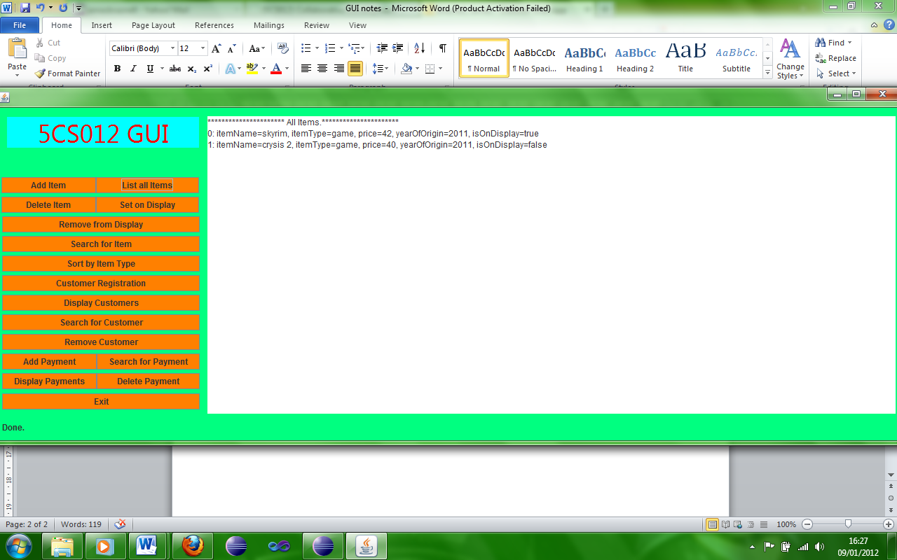

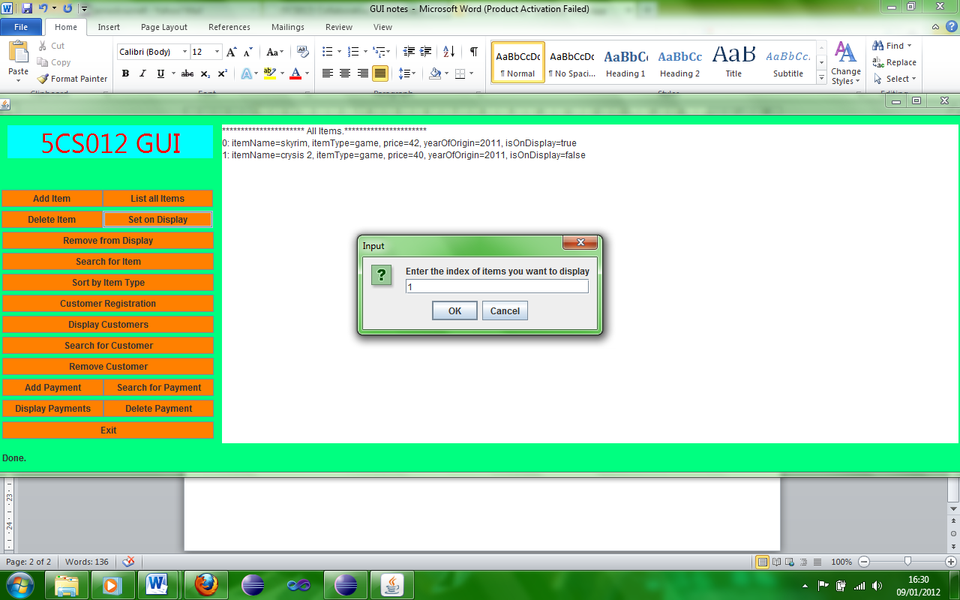Here the items are listed again and the third item has clearly been deleted.

In order to set an item on display click the appropriate button and enter the index of the item and then press ok.

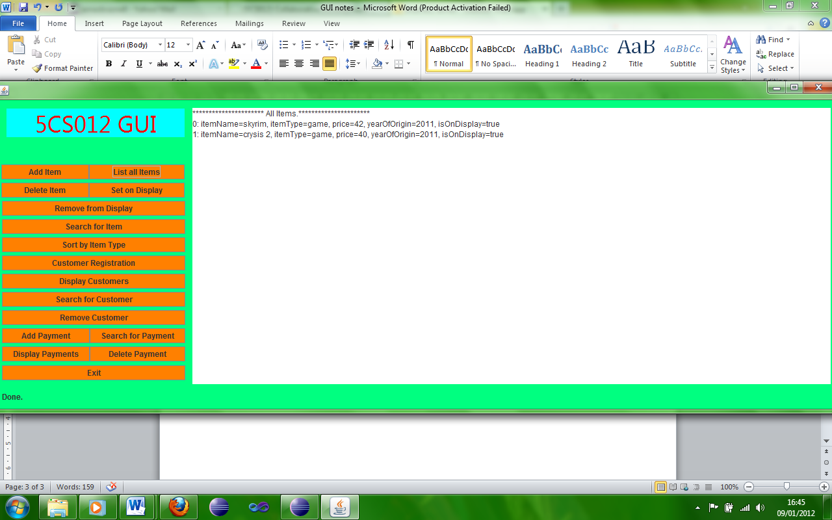

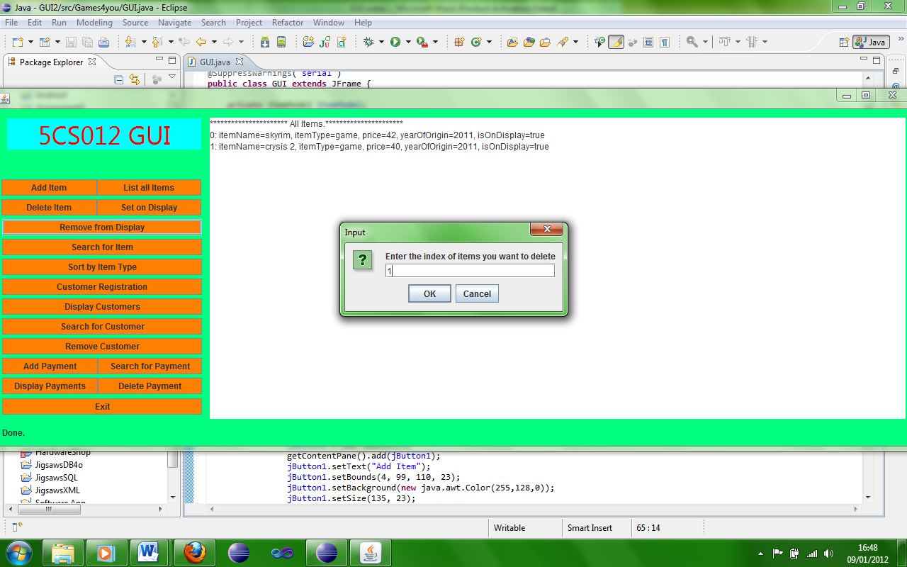Here the program clearly shows the item has been put on display.

In order to set an item on display click the appropriate button and enter the index of the item and then press ok.

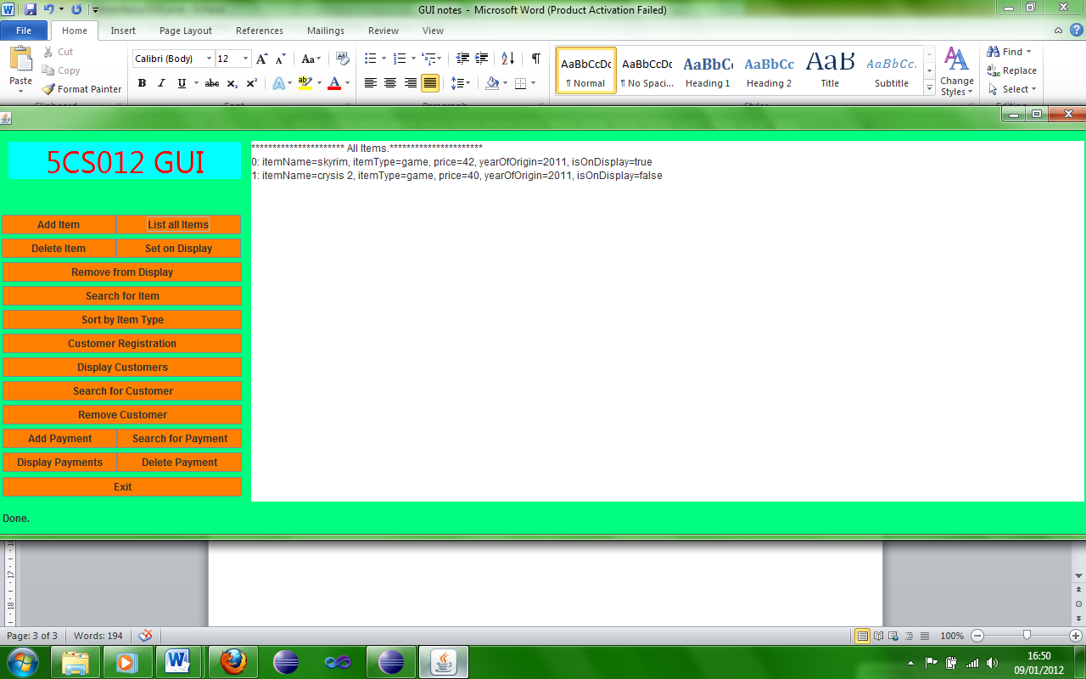

Here the program shows the item has been removed from display.

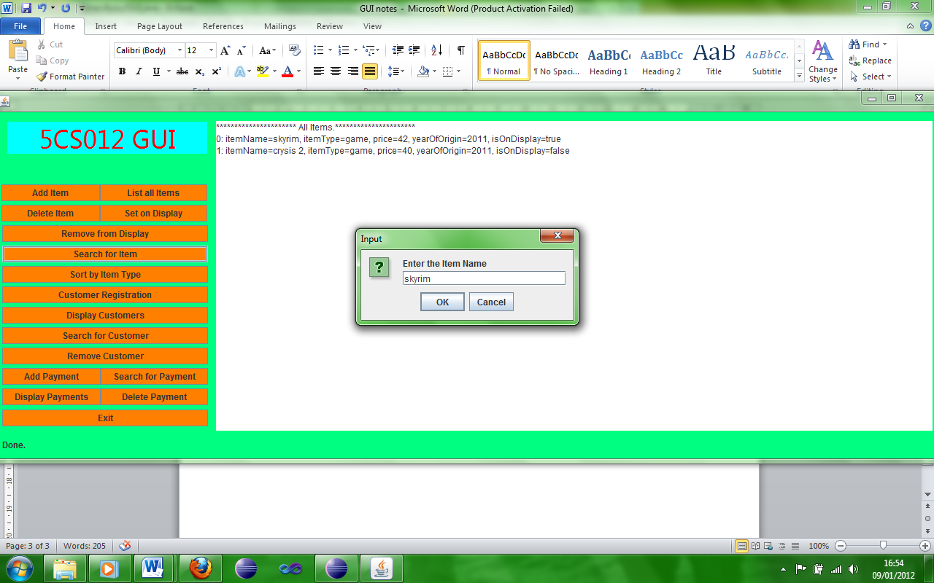In order to search for an item click the appropriate button and type the name of the item in the input box and press ok.

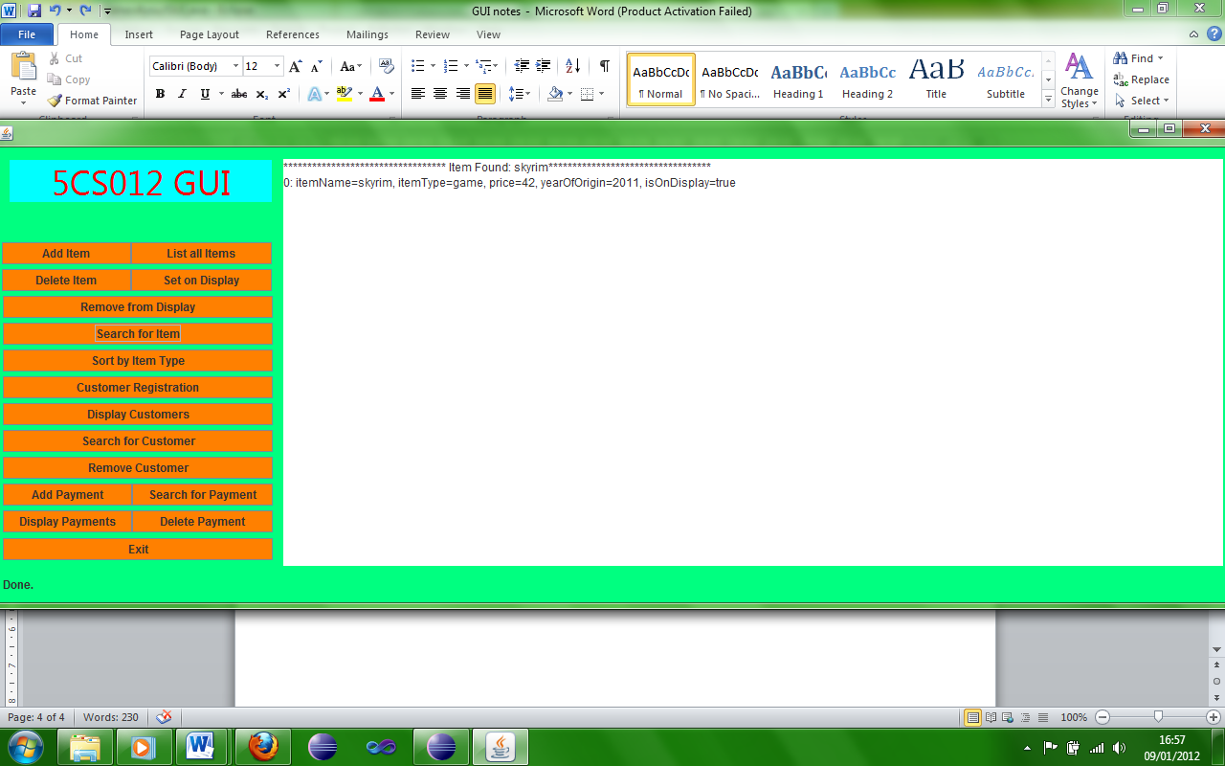

Here the program shows it has found the item and has clearly displayed it.

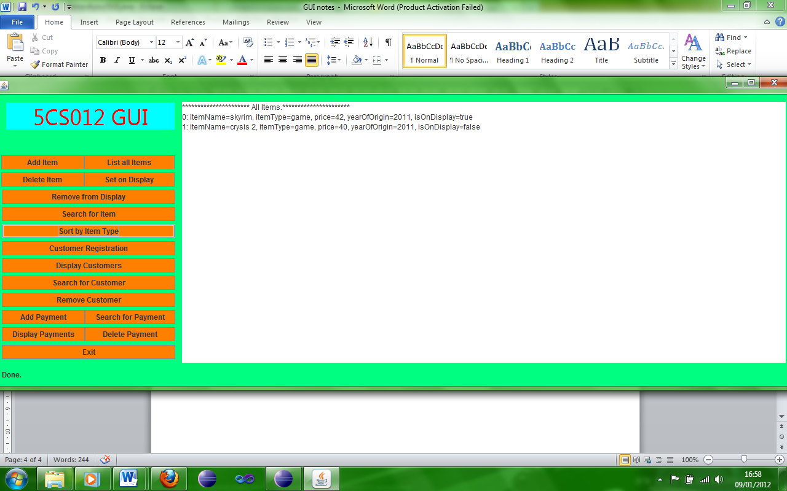

In order to sort the items by their type click the appropriate button and the program will display them as such immediately as shown here.

Some of these buttons shown above can be used for not only items but also for customers and payments and will do exactly the same as the respective counterparts above.

This program is meant for employees to be used to edit the items/customers/payments and in conjunction with the website it will update the database automatically.